Class: 5/____  Student’s name: ____________________________ | REVIEW 2
I. Look and write.
____get up___ | __________________ | _______________
_________________ | ___________________ | _____________________
II. Complete the sentence.
0. Minh __gets___ (get) up at six o’clock.
1. I __________ (brush) my teeth every morning.
2. They ______________ (not catch) the bus to school.
3. She _________ (have) breakfast with her family.
4. He _______________ (not walk) to school.
5. _________ Vinh _______ (have) a shower at night?
6. My mom _______________ (get) up at six thirty.
7. ________ Ly and Vy ________ (brush) their teeth at night?
8. What time _________ he ________ (start) work?
9. My friends ___________ (walk) to school.
10. What time ________ you ________ (have) dinner?
III. Read and circle the proper nouns.
My name is Ellen . My favorite movie in the world is Born Free. It’s a movie about a lion in Kenya. A woman called Joy Adamson helps a lion to live free in Africa. My dream is to go to Africa one day and see the lions living free.

IV. Look and write the time.
0. Nhan gets up at ___  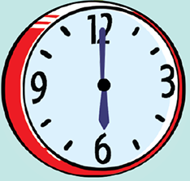  six o’clock_____. | 3. My sister goes to school at  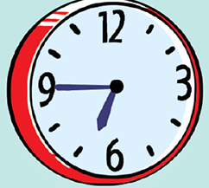  _______________.
1. She brushes her teeth at  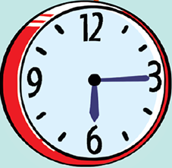  _________________. | 4. We get up at ____________  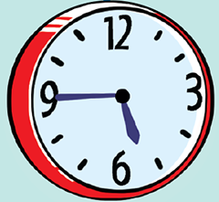  _______.
2. Nam gets dressed at  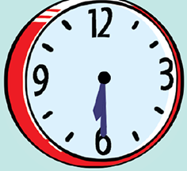  ________________. | 5. My dad goes to work at _____  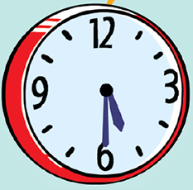  ____________.
V. Reorder the words to make a sentence.
0. get / I / . / early / up
I get up early.
1. has / with / . / Lam / family / her / dinner
____________________________________
2. not / they / . / catch / train / do / the
_____________________________________
3. time / you / ? / do / what / to / school / go
_____________________________________
4. have / every / we / day / breakfast /. /
____________________________________
5. six / does / get / ? / he / at / fifteen / dressed
_____________________________________
6. homework / . / the / her / evenings / she / in / does
_________________________________________
7. walk / . / hills / to / I / down / to / the / get / school
______________________________________________
8. a / cousin / . / not / my / big / live / house / does / in
_______________________________________________
THE END

